**Report on the program A from Assignment 2  
Computer Vision (CS-559)**

**Name: Dhaval Harish Sharma  
Red ID: 824654344**

**Introduction:**This program takes two images of a moving car as input and calculates the distance and speed of the car.

**Working of the program:**The program starts by importing the necessary libraries for its working. Skimage is used for converting the image to a numpy array as well as displaying the numpy array in the form of an image in the output. Initially, the two images are taken as input and converted to a numpy array containing the corresponding pixel values in the image. They are converted to grayscale with the help of rgb2gray function from skimage. We subtract the images to get the locations of car from both the images. Once the images are subtracted, it is thresholded in order to remove the noise from the image. After thresholding the image, there is still some salt and pepper noise in the output. Therefore, in order to remove this noise, the image is then processed through the modified median filter in order to remove the salt and pepper noise. Then, we invert the image, so that the cars in the image appear white with the black background. After getting an inverted image, we detect the cars which appear as blobs in the image by using blob_doh function from skimage. From this, we get the pixel values of both the cars. The program is now ready to calculate the distance travelled by the car. The total distance of the frame and time between both frames is known to us. Then, we find the distance travelled by the car according to the ratio of the distance of the image frame and the distance travelled by the car. After finding the distance travelled by the car, we get the speed of the car according to the equation “speed = distance / time”. Finally, we display the processed image.

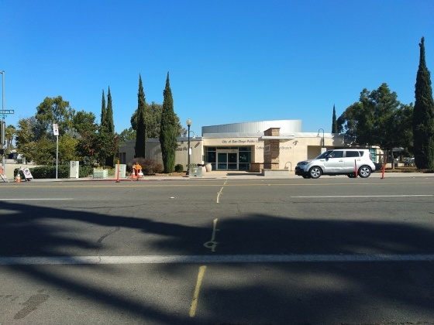 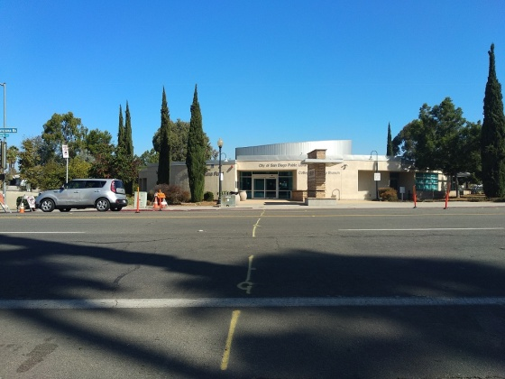  
Image 1 Image 2

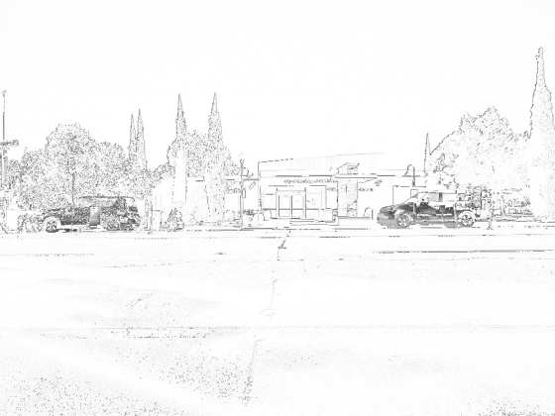 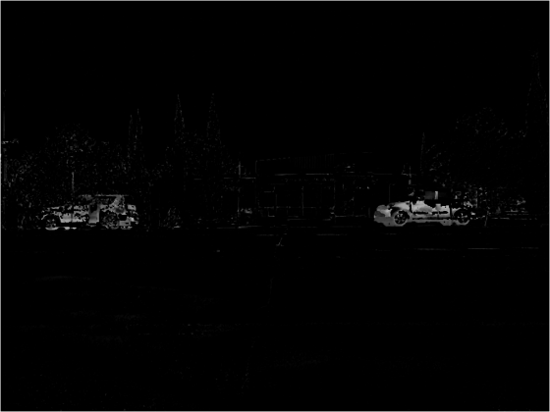  
Image after thresholding Image after applying filter

**Findings:**Theoretically if we subtract two images, we get only the objects which changed in both the images, but in practical operations, there are always some moving objects in the picture due to the external factors such as wind, movement of the camera, etc. In the same way, after subtracting the images, there were some additional black pixels as noise which was unwanted. Thresholding operation was needed in order to reduce this kind of noise. After thresholding, there were some salt and pepper noise in the image, which was removed with the help of ordered filter. In addition to this, we should also know the ratio of camera frame distance to the moved car distance in order to calculate the speed.

**Conclusion:**In conclusion, finding the speed of the car is a complicated task as it consists of several minute details to take in to consideration. But, once they are taken care of, we can find the speed of a car with good accuracy.